Tableau Assignment

Table of Contents

Chapter 1. Calculations and Statistics 2

Chapter 2. Advance Chart Types 3

**Note: Use sample superstore subset datasource that comes by default with Tableau installation to complete below exercises.**

# Chapter 1. Calculations and Statistics

Q1. Create a calculated Field to Separate Customer name into First Name and Last Name.

Hint: Use Split Function in tableau.

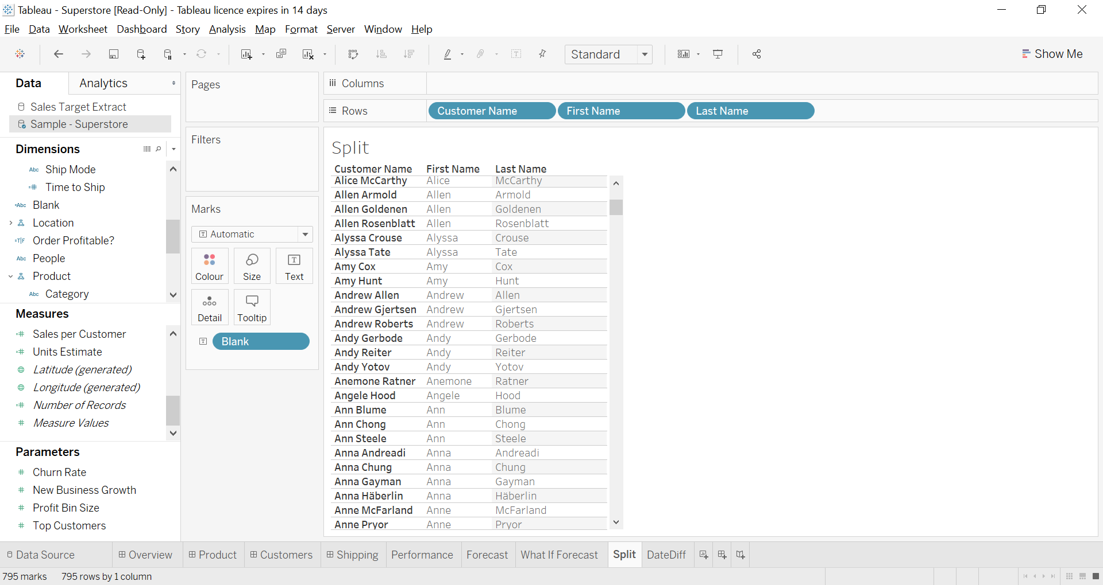

Q2 .Create a calculated field to compute gap between Order Date and Ship Date.

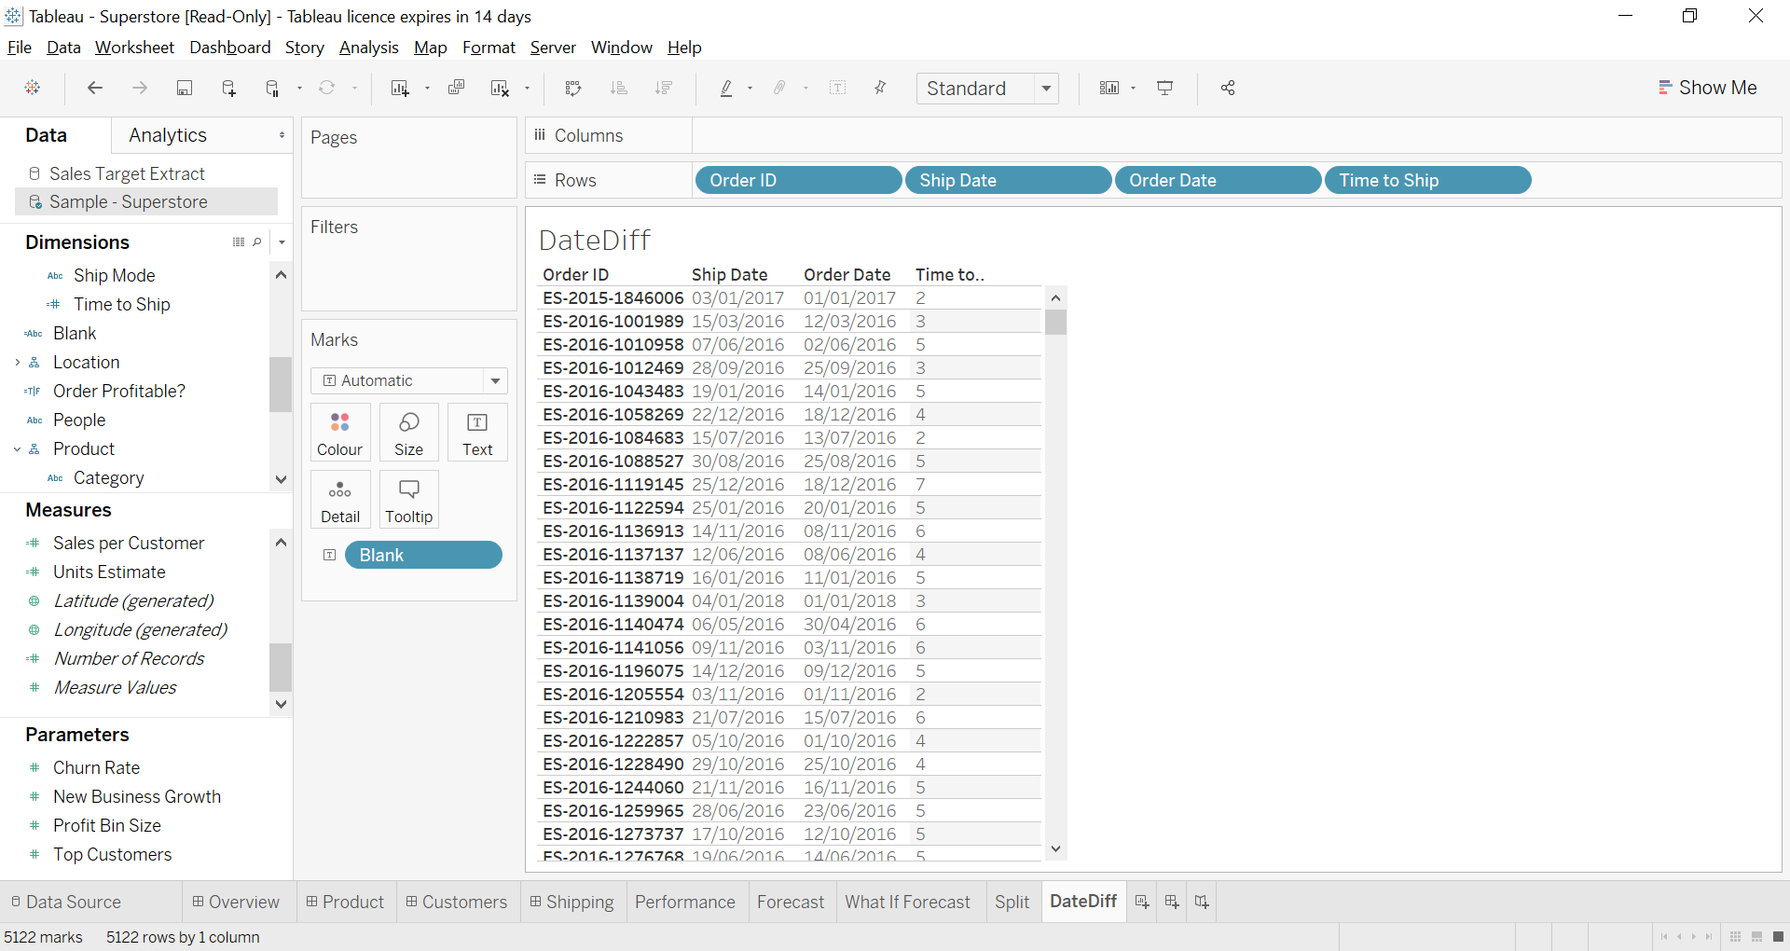

Q3. Create a calculated field to return a week number from Order date.

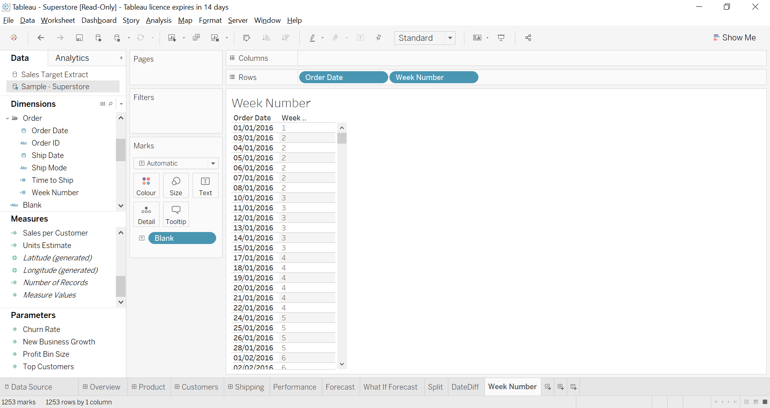

Q4. Create a calculated field to return sales based on different values of ship mode. Hint: Use IF ELSE or CASE function.

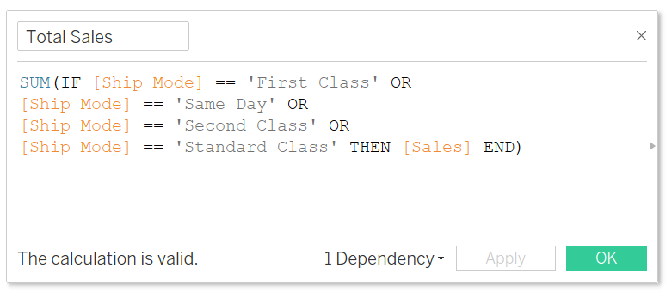

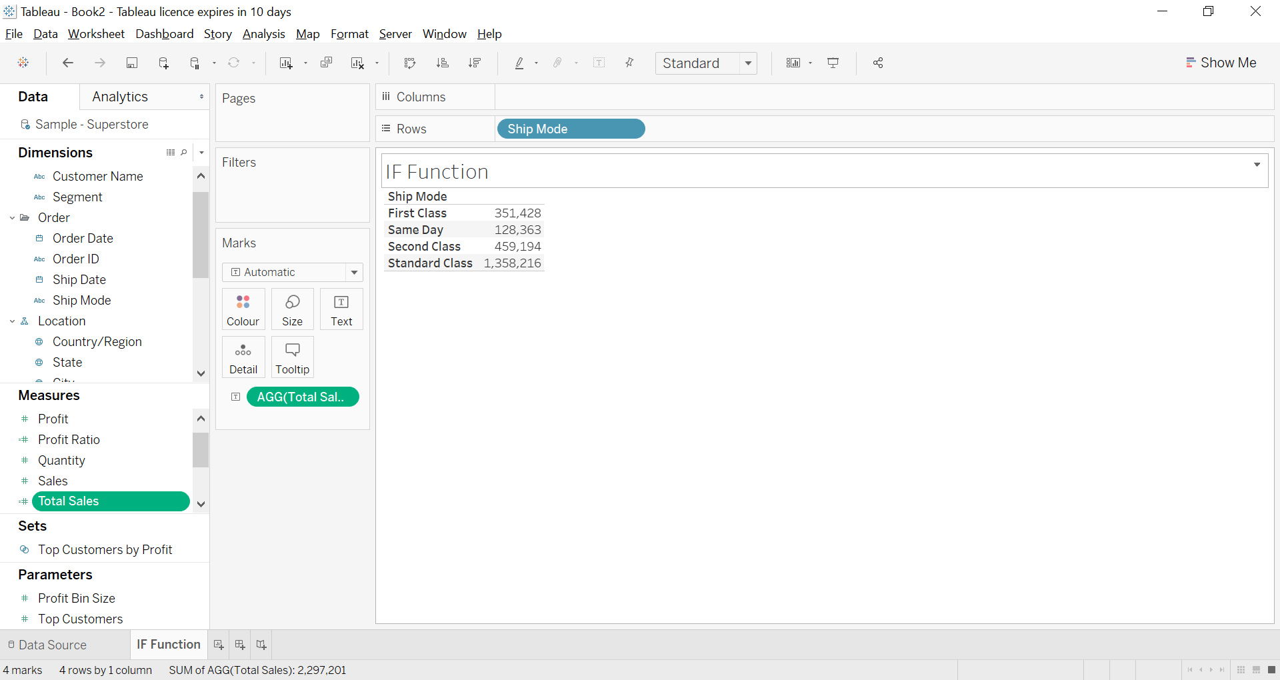

Q5. Use a quick table calculation to show the rank of each customer based on profit.

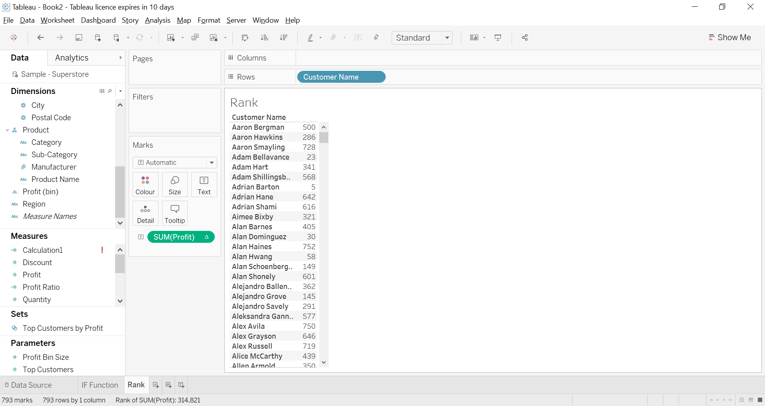

Q6. Create a Calculated field to show Profit Ratio in percentage.

(Hint: Profit ratio is Net profit divided by Net Sales.)

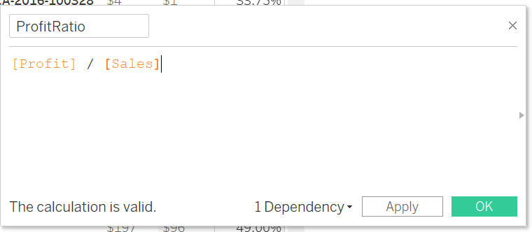

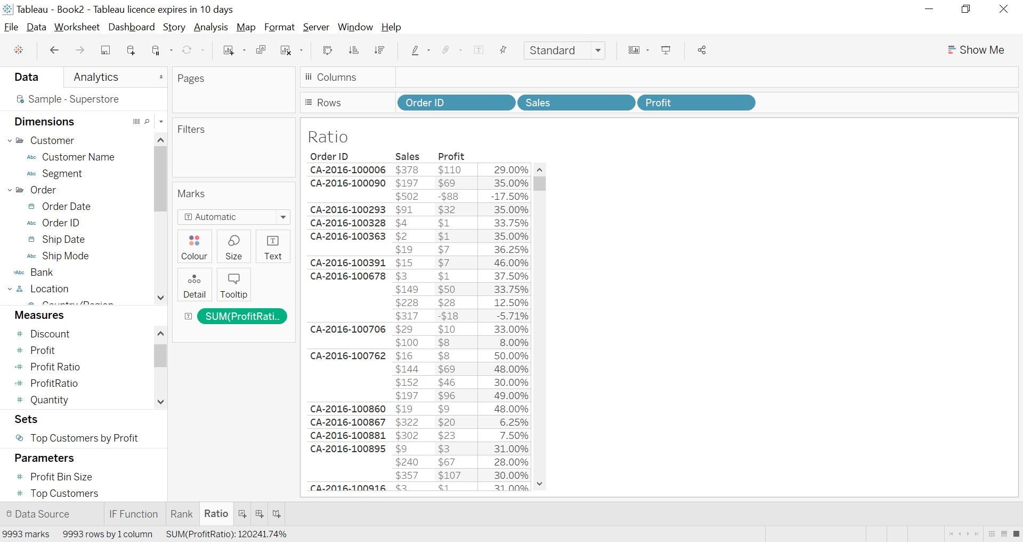

Q7. Create a calculated field to return sales based on different values of Category.

Hint: Use CASE function.

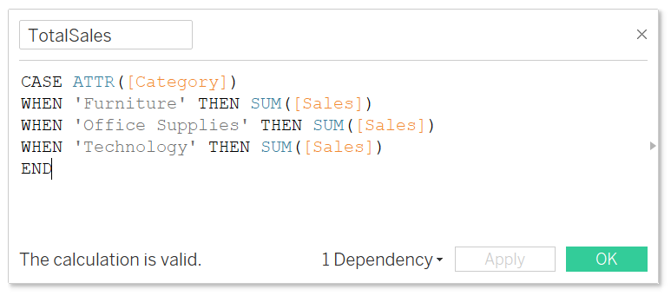

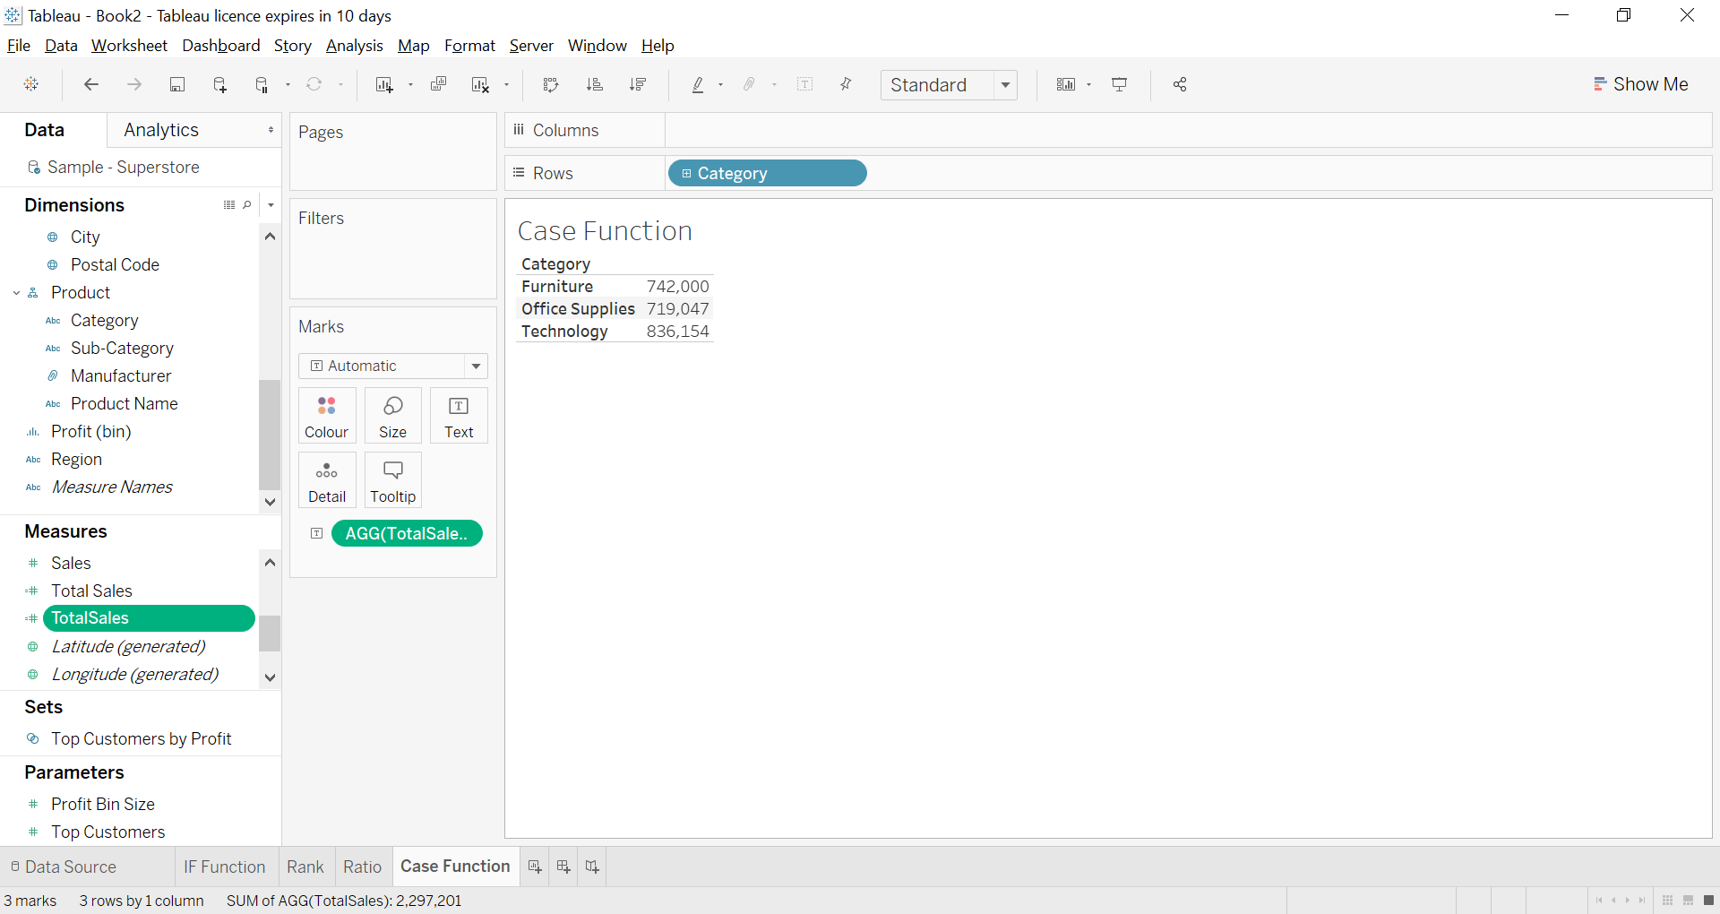

Q8. Create a graph using Month of Order Date and Running total of Sales. Use calculated field to compute running sales.

(Hint: Use function to compute running sum)

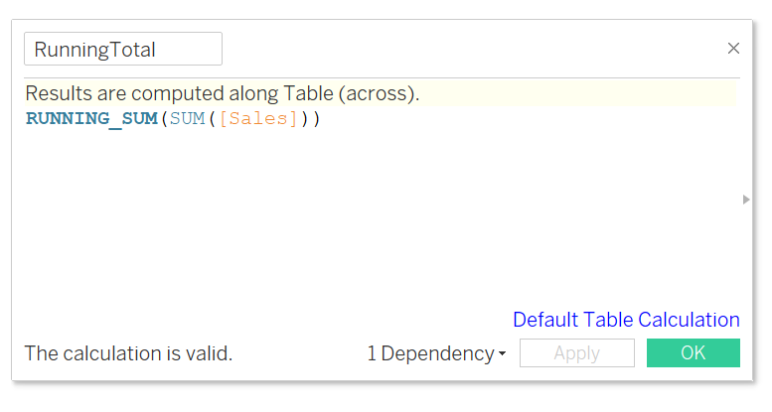

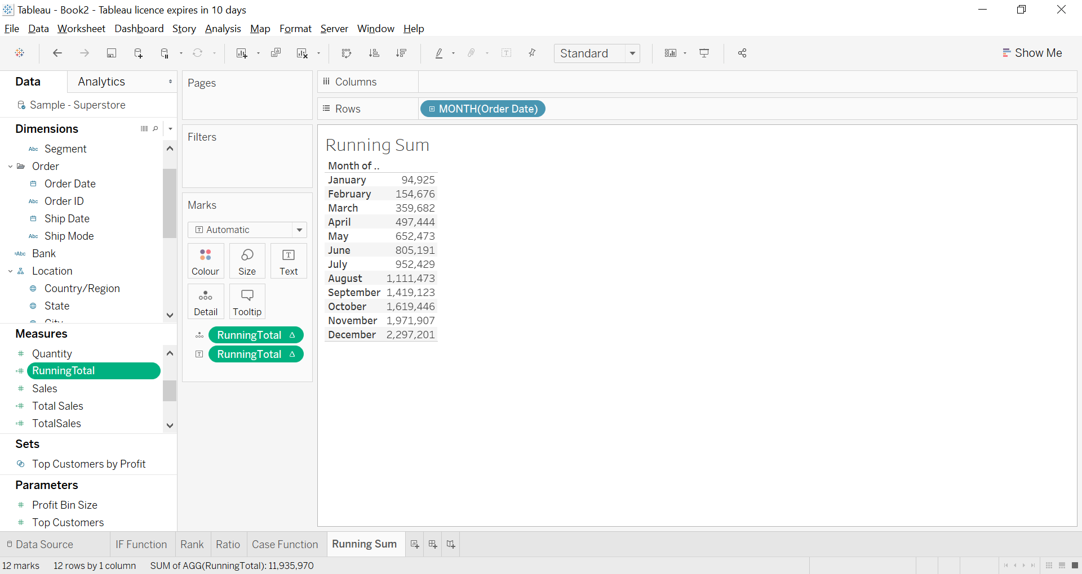

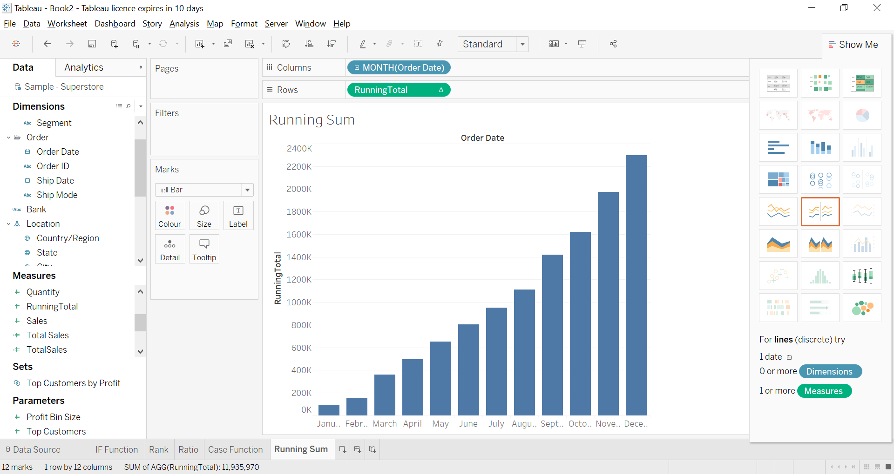

Q9. Create a calculated field to show difference in sales between Current Year and Previous Year in percent (%).

(Hint: Use Lookup or Window Sum Function)

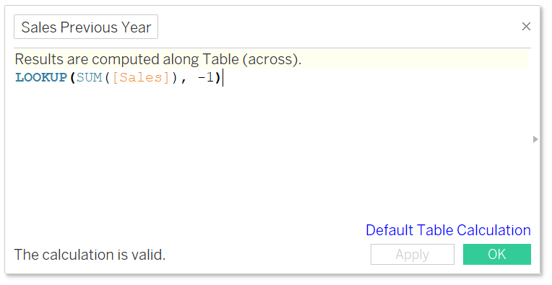

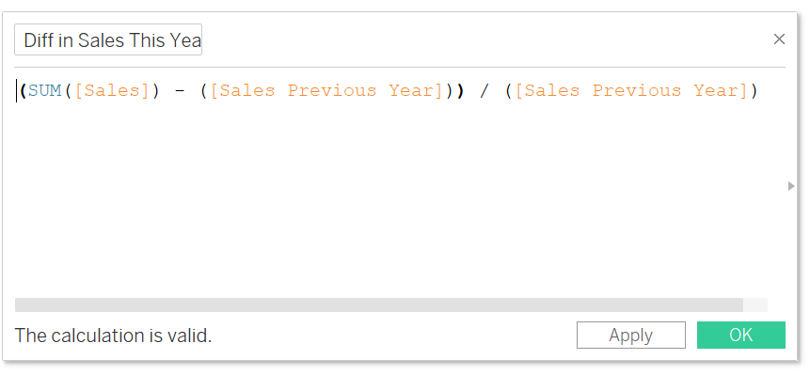

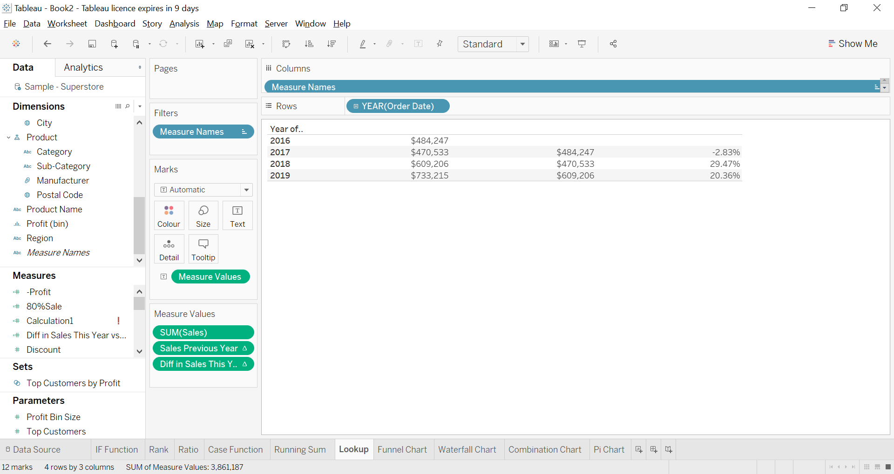

# Chapter 2. Advance Chart Types

Q1. Create Funnel chart for Sales by Sub– Category

• Labels for Sub– Category and Sum of Sales.

• Sales in Units of K (Thousand) and Currency in $.

• Negative Axis Should not Contain any Labels or Values in Tooltip.

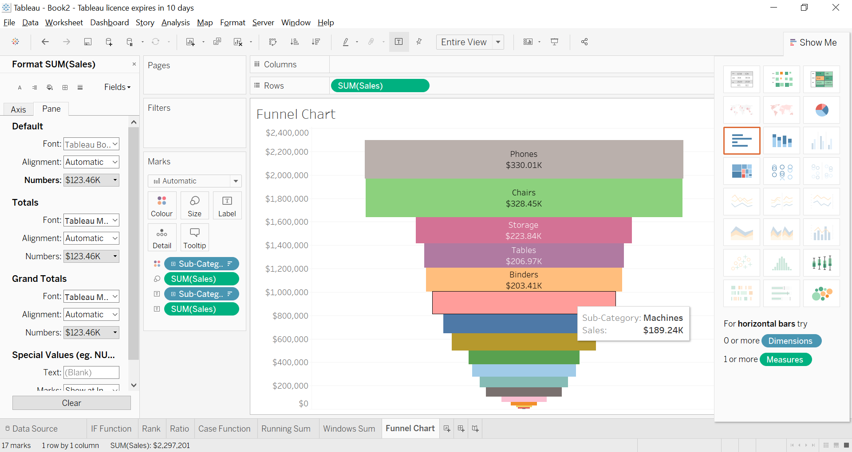

Q2. Create a waterfall model for running total of profit against Product Sub-Category. Also, add Row Grand total.

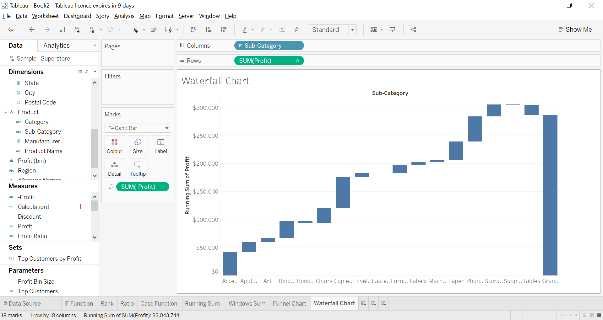

Q3. Create a view with a line showing 80 % amount of sales across several months and a bar chart showing actual sales attainment for the months.

Use Combination Chart.

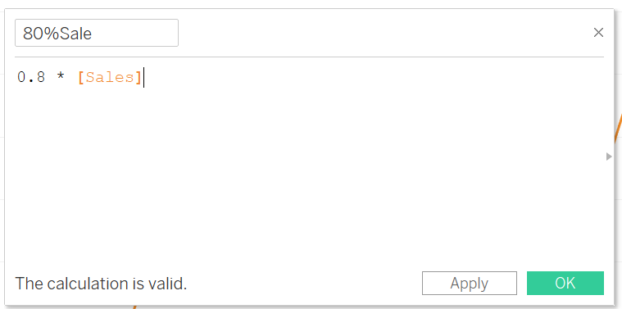

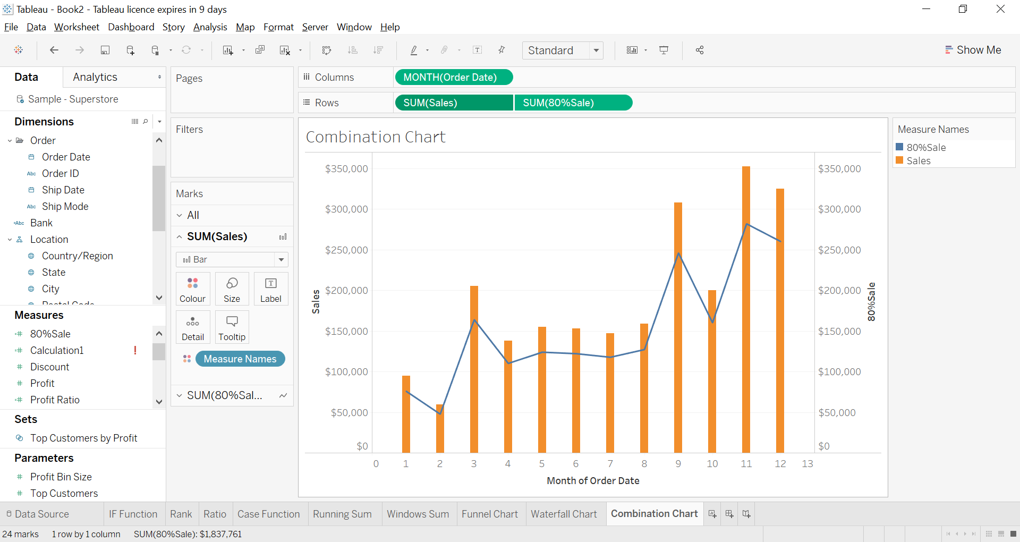

Q4. Apply Filter on Country and set value"United States". Create a Pie chart for Sum of sales across shipping mode for each state (in U.S.A.) in where states are colored by Profit.

• States should have labels.

• Pie Chart should have white Border.

